**MySQL Workbench Export**

**Deliverables for database project assignments**

To complete this assignment, submit the following two files to Webcourses:

1. An SQL file (i.e. save the file with file extension .sql) containing the SQL written to perform the tasks in an SQL code friendly editor (e.g. Brackets).
2. **An exported SQL file using MySQL Workbench Data Export option. The file name should be the following format: FirstnameLastnameAssignment#.sql. Example: KarinWhitingAssignment2.sql**

**To export from MySQL Workbench**

1. Launch MySQL Workbench



1. Click on the Local instance MySQL icon

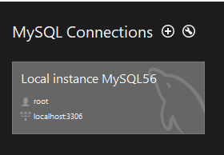

1. Enter the database password

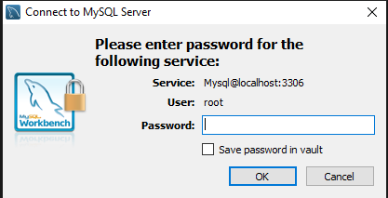

1. Click on Data Export

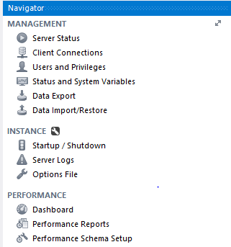

1. On the Data Export UI do the following
   1. Select the database to export
   2. Select Export to Self-Contained File
   3. Click on the ellipsis to select the directory to save the file to
   4. Click the checkbox for Create Dump in a Single Transaction
   5. Click the checkbox for Include Create Schema
   6. Click the Start Export button

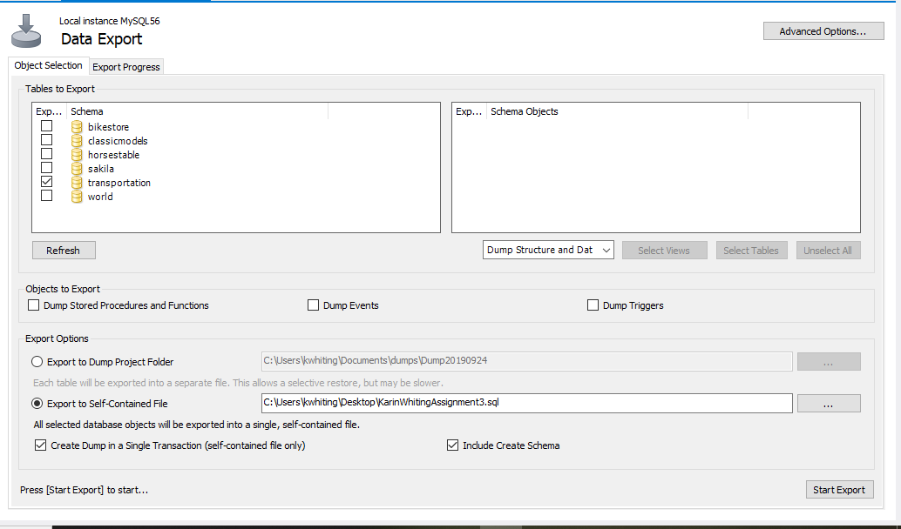

1. The completion of export will be reported

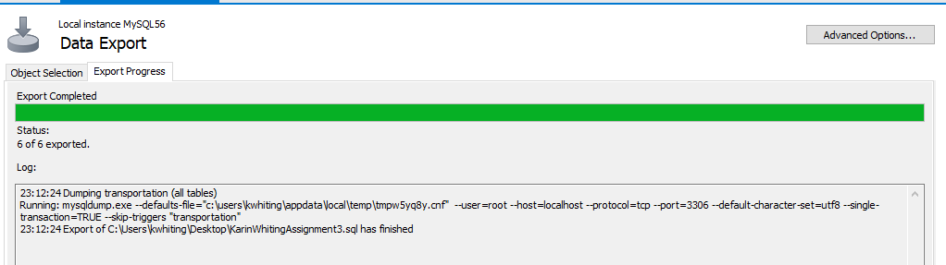

1. Exported data file will look similar to the following

